The initial materials are P(VDF-TrFE-CFE), the molar content ratios are: 66.1/28.3/5.6, chemical structures are shown as figure 1. You can roughly use VDF/TrFE as 2/1 and CFE = 5% of the total monomers.

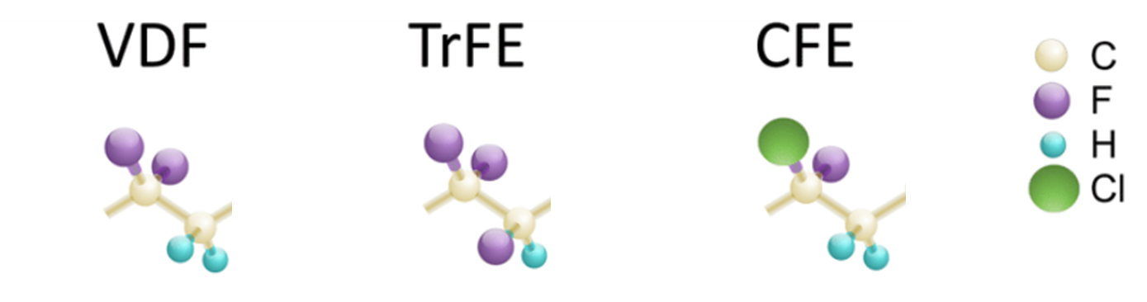

Figure 1

The DB was locally converted from CFE. From 0% DB to 4% DB, we found the estimated phase content close to the data shown in figure 2. At around 2.7% DB, the materials are close to the 3 phase coexisting phase boundary, where the piezoelectric constant reach the maximum.

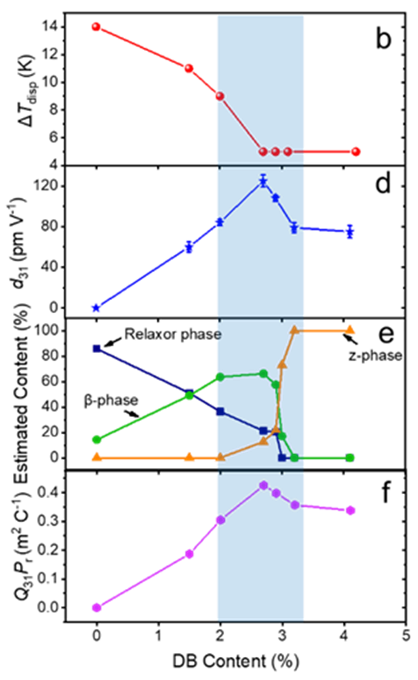

Figure 2

We need to calculate the energies for β-phase (dihedral angle close to 180o) , relaxor phase (helical and α, tgtg’ or tgtgtg/tg’tg’tg’, dihedral angle close to 60o and 3000), and z-phase (twisted from β, maybe 150?, after relax, we can discuss to define).

For now, what we know are DB can twist the chain, as shown in the figure 3

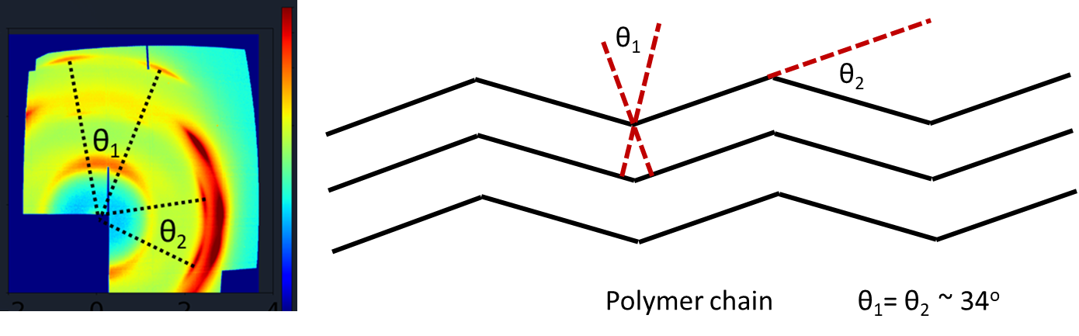

These θ in reciprocal space may be different from the real space, I will do the estimation.

I suggest you can calculate DB = 0, 1, 2, 3, 4, 5, the corresponding CFE will be reduced as 5, 4, 3, 2, 1, 0.

I will send the lattice parameters to you once I roughly figure out them.